H.T No
Regulations:
A15


Sreenidhi Institute of Science and Technology
(An Autonomous Institution)
Code No: 5A304 Date: 30-Dec-2019 (FN)

B.Tech II-Year I-Semester External Examination, Dec-2019/Jan-2020 (Supplementary)
Circuits and Networks-II (EEE)

Time: 3 Hours Max.Marks:75

Note: a) No additional answer sheets will be provided.
b) All sub-parts of a question must be answered at one place only, otherwise it will not be valued.
c) Missing data can be assumed suitably.

Part - A Max.Marks:25

Answer all QUESTIONS.

1. | Write about phase voltage and current of a three phase system. | [3M]
2. | In a balanced three phase system, the power is measured by two-wattmeter method and the ratio of two wattmeter readings is 4:1. The load is inductive. Determine the load power factor. | [3M]
3. | Find the differential equation for the current i(t) in the below network.  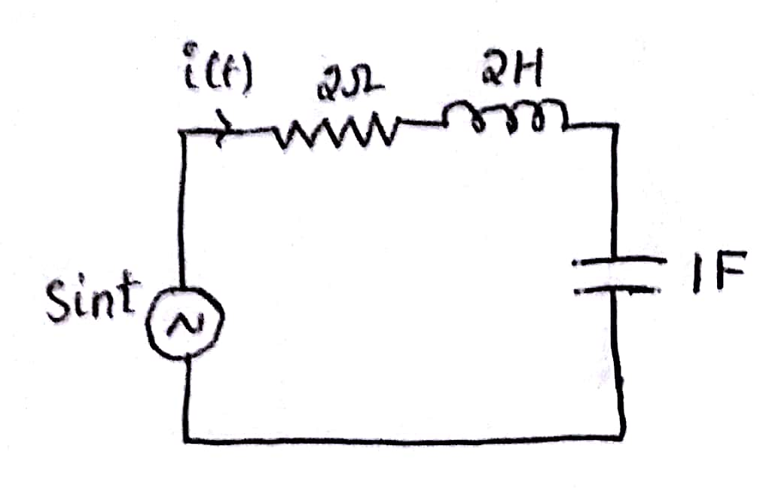 | [3M]
4. | The network shown in below figure has acquired steady state with the switch closed. At t=0, the switch is opened. Find i(0⁻) and i(0⁺).  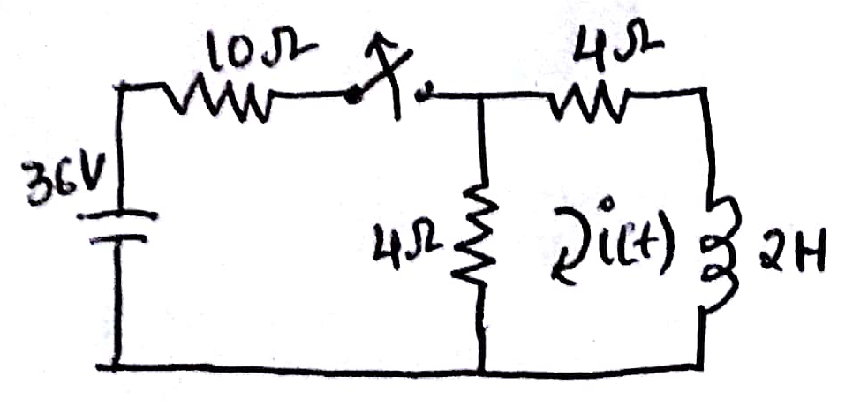 | [3M]
5. | Find poles and zeros of the impedance of the network shown in below figure. 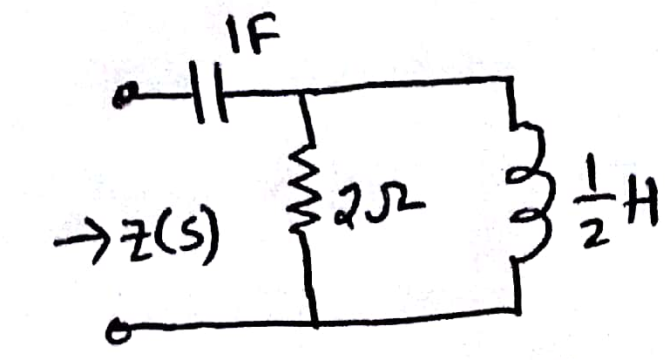 | [3M]
6. | For the network shown in below figure plot poles and zeros of current transfer function. 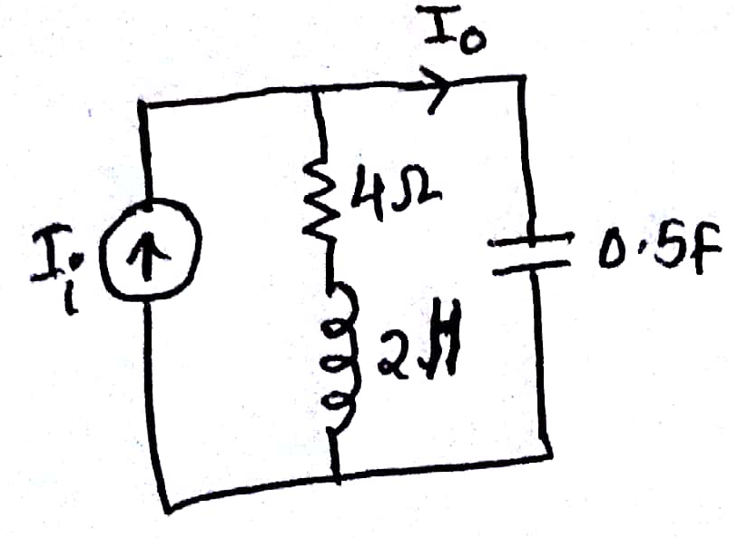 | [2M]
7. | Test results for a two port network are (i) I₁=0.1A , V₁=5.2V, V₂=4.1V with port-2 open-circuited (ii) I₂=0.1A, V₁=3.1V, V₂=4.2V, with port-1 open- circuited. Find Z-parameters. | [2M]
8. | Find π-network for the given Y-parameters, Y₁₁=1/2, Y₁₂=Y₂₁=-1/4, Y₂₂=5/8. | [2M]
9. | Why filters are used in networks. Classify filters. | [2M]
10. | A complex wave of 240V rms value has 20% third harmonic content, 5% fifth harmonic content and 2% seventh harmonic content. Find the rms value of the fundamental and each harmonic. | [2M]
Part – B Max.Marks:50
ANSWER ANY FIVE QUESTIONS. EACH QUESTION CARRIES 10 MARKS.

11. | a) | A balanced three-phase system with a line voltage of 300V is supplying a balanced star connected load with 1200W at a leading power factor of 0.8. Find the line current and the per-phase load impedance. | [5M]
 | b) | A three phase supply with a line voltage of 250V has an unbalanced delta-connected load as shown in below figure. Determine (i) phase currents, (ii) line currents, (iii) total active power and (iv) total reactive power, if phase sequence is ABC.  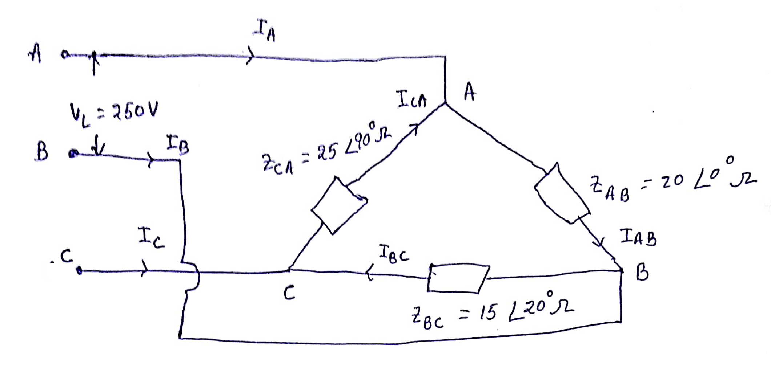 | [5M]
12. | a) | In the network of below figure, the switch is closed and steady-state is attained. At t=0, switch is opened. Determine the current through the inductor using Laplace transform.  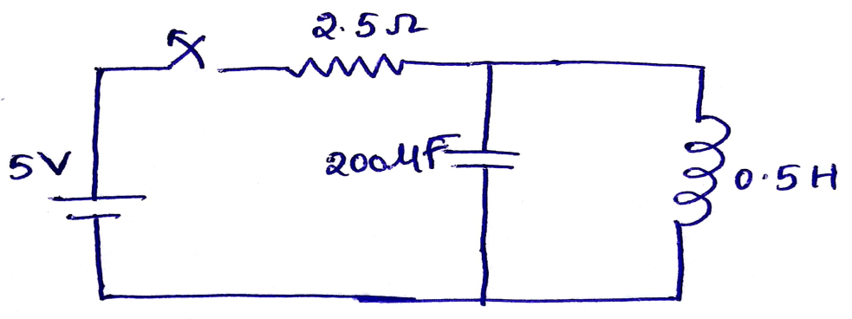 | [5M]
 | b) | The switch in below figure is opened at t=0. Determine the voltage v(t) for t > 0 using Laplace transform.  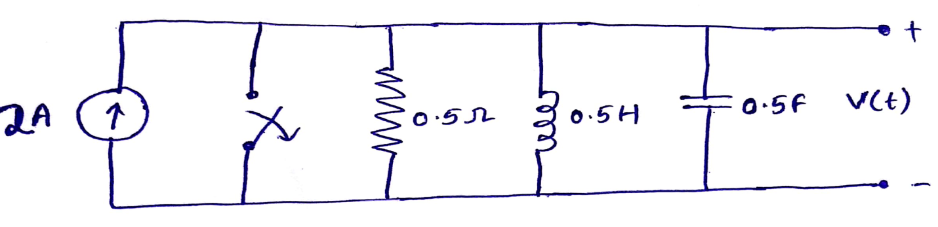 | [5M]
13. | a) | Determine the voltage transfer function V₂/V₁ for the network shown in below figure.  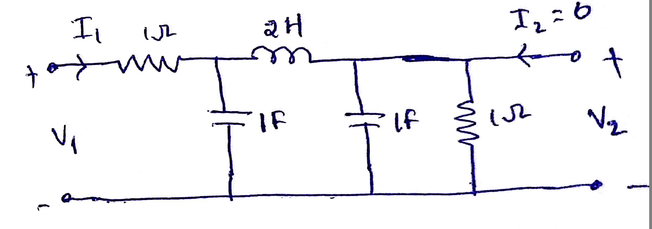 | [5M]
 | b) | For the network shown in below figure, plot poles and zeros of transfer function of I₀/I_{i}.  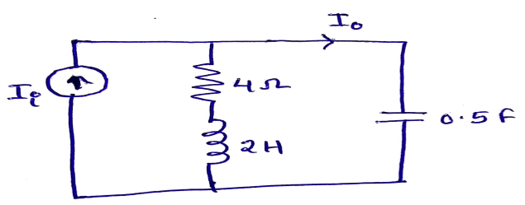 | [5M]
14. | a) | Two identical sections of the network shown in below figure are connected in series. Obtain Z-parameters of the overall connection.  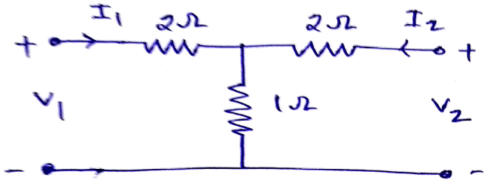 | [5M]
 | b) | Determine Y-parameters for the network shown in below figure.  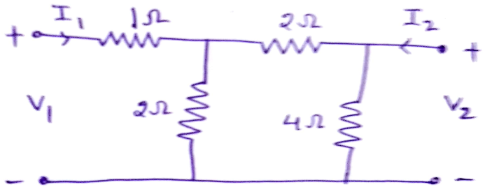 | [5M]
15. | a) | Each of the two series elements of a T- section low pass filter consists of an inductor of 60mH having negligible resistance and a shunt element having a capacitance of 0.2µF. Calculate (i)the cut off frequency, (ii)nominal impedance and (iii)characteristic impedance at frequency of 1kHz. | [5M]
 | b) | Design a band pass constant-k filter with cut off frequencies of 4kHz, 10kHz and nominal characteristic impedance of 500Ω. | [5M]
16. | a) | Find the exponential Fourier series of the waveform shown in below figure. Draw the magnitude spectrum.  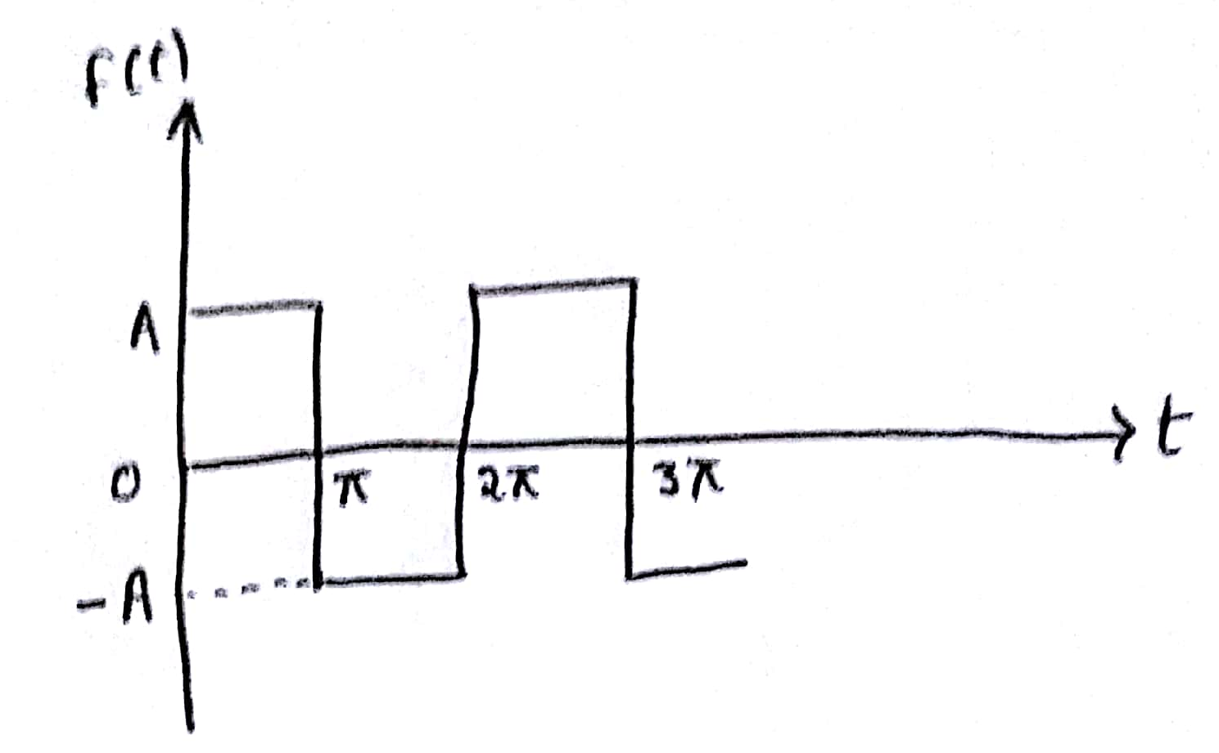 | [5M]
 | b) | Find the Fourier transform of the function shown in below figure.  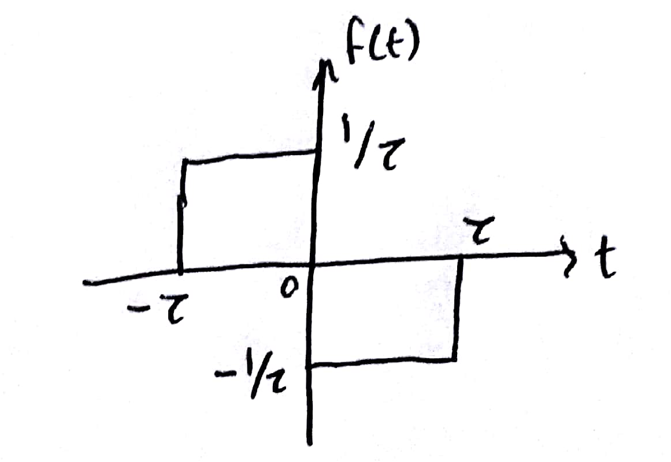 | [5M]
17. | a) | Obtain an expression for phase angle of delta connected load by using two watt meter method and by using necessary phasor diagrams? | [4M]
 | b) | Derive exponential response of series RL circuit. | [3M]
 | c) | Write the restrictions on pole locations for transfer functions. | [3M]
18. | a) | Express h-parameters in terms of Z and ABCD parameters? | [4M]
 | b) | Find the values of shunt and series element of each half section of a constant-k T-section high-pass filter. The termination is 600Ω and the filter is cut off below 20kHz. | [3M]
 | c) | Derive expression for frequency convolution in Fourier expansion. | [3M]
-- 00 -- 00 –

